COAL LAB 6
Task 1:
include Irvine32.inc

.data
num1 dword ?
msg byte "Enter a number: ",0

.code
main PROC
mov ebx,1
mov ecx,10
mov edx,offset msg
call writeString
call readInt
mov num1,eax
L1:
mul ebx
call writeInt
call crlf
mov eax,num1
INC ebx
Loop L1

exit

Main endp
end main
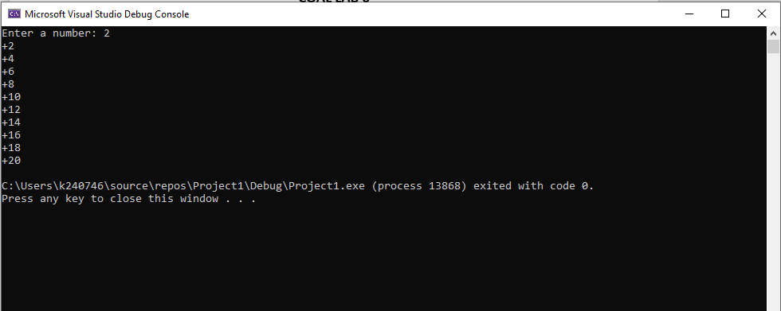

Task 2:
include Irvine32.inc

.data
num1 dword ?
fact dword ?
msg byte "Enter a number: ",0

.code
main PROC
mov edx,offset msg
call writeString
call readInt
mov num1,eax
dec num1
mov ecx,num1
L1:
mul ecx
Loop L1
mov fact,eax
call writeInt

exit

main endp
end main

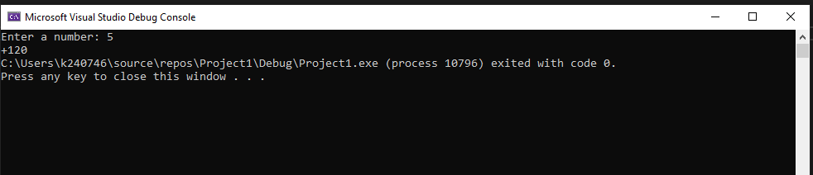

Task 3:
include Irvine32.inc

.data

.code
main PROC
mov eax, 20
mov ebx, 10
cmp eax, ebx
call DumpRegs

mov ebx, 10
mov eax,10
cmp eax, ebx
call DumpRegs

mov eax, 5
mov ebx, 10
cmp eax, ebx
call DumpRegs

exit

main endp
end main

